Quotation List for Sponsorship

Type A. Exhibition Booth for Equipment and Catalogues

1. Quotation
￥ 150,000 JPY (including Consumption Tax)

2. Description of Facilities
Project | Unit |  | Size | Contents
Booth | 1 |  | W2,400mm × D900mm × H2,100mm
Table | 1 |  | W1,800mm × D600mm × H700mm | With white table cloth
Name Plate | 1 |  | W900mm × H200mm | Black Gothic Letter on White Plate
Chairs | 2 |  |  | Stacking pipe chair
Spot Lighting | 1 |  |  | Dichroic halogen bulb(75W)
Power Supply | 2 |  |  | 100V 500W Power outlet with ground earth

※Water supply and drainage are not available in the booth. Please refrain from using chemical, medical or water.
※If required power supply capacity is over 500W, further power supply could be provided with additional services fee.

3. Others
Booth Images

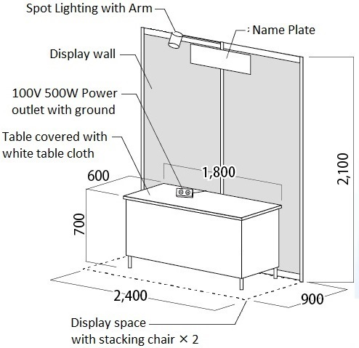

  - The guideline on installation/removal of a Booth on the day of preparation will be sent around January 2023.
  - Exhibitors are required to bear all the related workload and expenses for the event, including but not limited to transportation, unpacking, installation, packing and removal of the items installed by the exhibitor, restoration of the original situation, etc.
  - The secretariat will arrange the allocation of booths and inform the allocation after the deadline.
  - If necessary, some adjustments of application details might be requested by the secretariat.
  - The secretariat will manage the venue, but not be responsible for any damages such as theft, loss or disasters of the exhibition.

Type B. Exhibition Booth for Catalogues

1. Quotation
￥ 50,000 JPY (Including Consumption Tax）

2. Description of Facilities
Project | Unit |  | Size | Contents
Table | 1 |  | W 1,800mm × D 600mm × H 700mm | With white table cloth

※Neither panel display wall nor chair will be provided. Exhibitors who want to display the panels are kindly requested to apply Type A Exhibition Booth.

3. Others
Booth Images

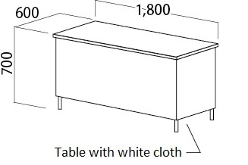

  - The secretariat will arrange the allocation of desks and inform the allocation after the deadline.
  - If necessary, some adjustments of application details might be requested by the secretariat.

Type C. Advertisement in the Program Bulletin

- Quotation List
Specification | Volume | Unit Price  （Including Consumption Tax）
Back Cover | A4 Full Size | \100,000
Inside Front | A4 Full Size | \70,000
Inside Back | A4 Full Size | \70,000
Inside Page Full Page | A4 Full Size | \50,000
Inside Page ½ Page | A4 Half Size | \30,000

- Others
  - The Program Bulletin will be distributed to ACID RAIN 2020 participants. Total volume of Bulletin is about 500 copies.
  - The secretariat will arrange the publication order of advertisements in Inside Pages and will inform the exhibitors（except for Back Cover, Inside Front Cover and Inside Back Cover）.
  - If necessary, some adjustments of application details might be requested by the secretariat.
  - An Outline Form with a full version of the data is requested to be submitted before the deadline. The organizer will not implement any proofreading or translation. The Format of PDF (X1A format) or Adobe Illustrator or Photoshop data format is recommended.
  - An output sample in format of JPEG (illustrator export), screen shot or PDF (scanned) should be attached in order to prevent from any omission of images and characters.

